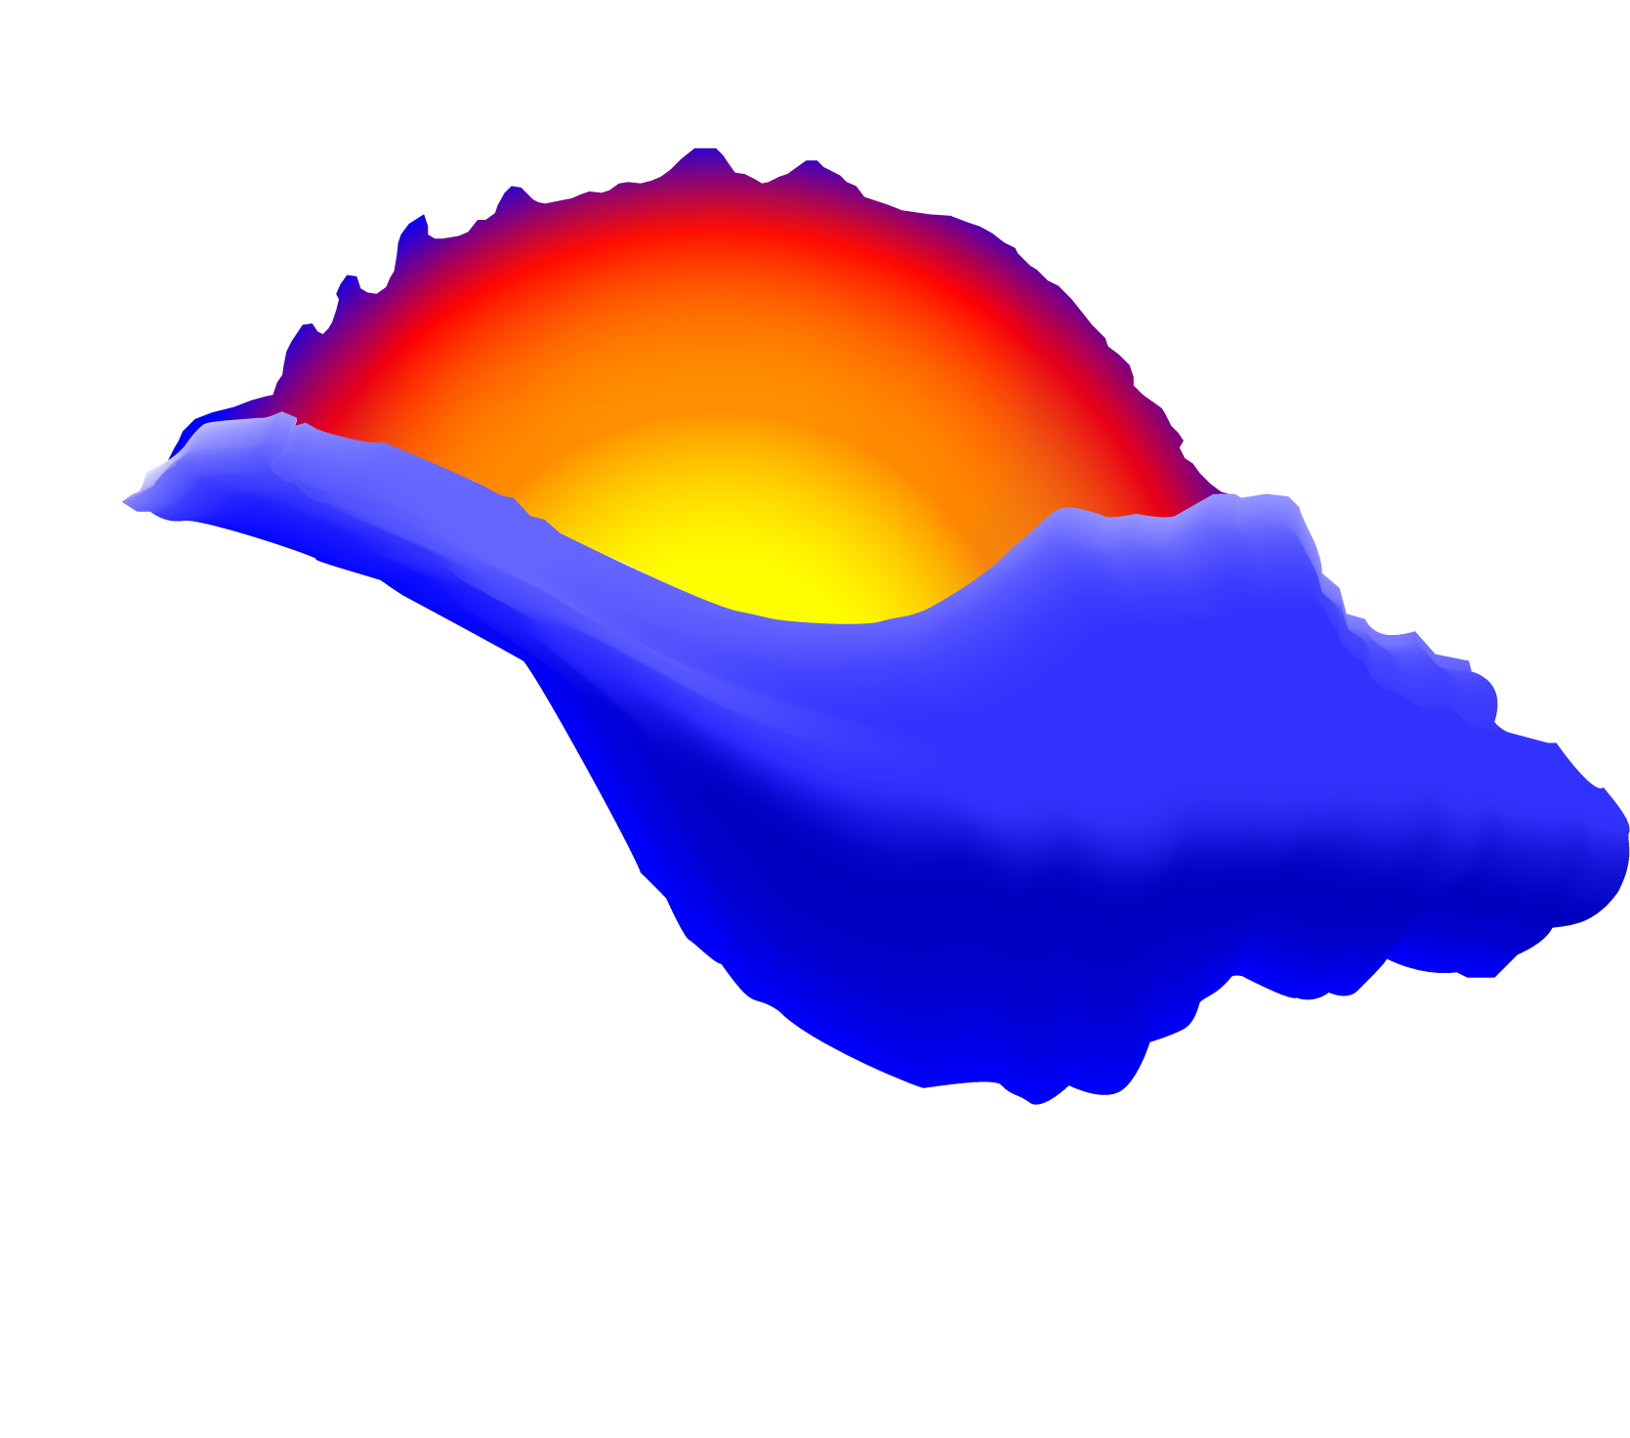
EFT (Emotional Freedom Techniques)
Level 1 Training Manual
Compiled by Ranjana and Eddie Appoo
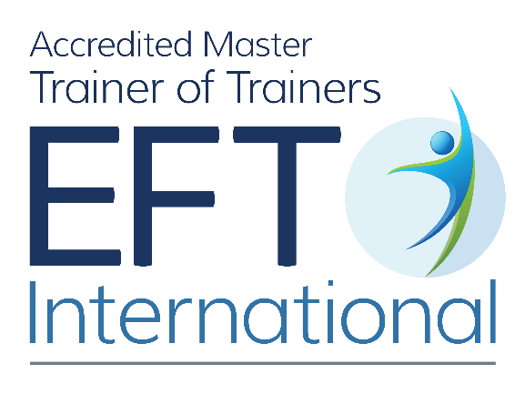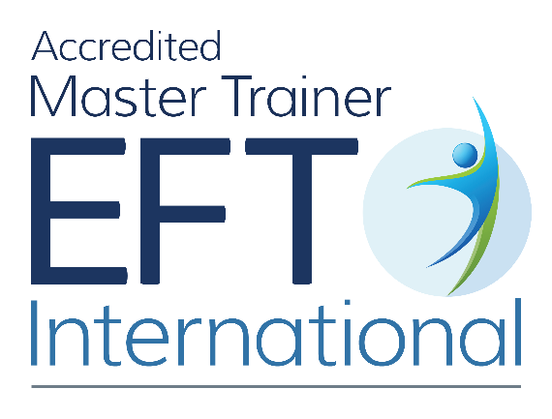

1
Disclaimer and Release Agreement
Emotional Freedom Techniques (EFT) is part of an evolving new discipline of treatment techniques and protocols referred to as Energy Therapy. While still considered experimental, therapists, nurses, physicians, psychologists and lay people worldwide, use these techniques successfully. To date, Energy Therapy Techniques have yielded exceptional results in the treatment of psychological and physical problems. They are NOT, however, meant to replace appropriate medical treatment or mental health therapy. We did not experience any adverse side effects when applying these techniques when the treatment protocols and suggestions were followed. This does not mean that you or your clients will not experience or perceive any side effects. If you use these techniques, download the audios mentioned, and/or try the Sequences on yourself or others, you agree to take full responsibility for your own well-being, and you advise your clients to do the same. Before beginning any new health regimen, i.e. diet, exercise, yoga, martial arts, meditation or Emotional Freedom Techniques, check with your doctor or primary care physician.
We accept no responsibility or liability whatsoever for the use or misuse of the information and audio downloads provided on our website, including but not limited to; LiberatingTouch®, EFT (Emotional Freedom Techniques), Jin Shin Jyutsu, and related activities. By reading or downloading this book, you agree and understand that this Disclaimer is a Release Agreement, and is intended to be a complete unconditional release of liability and assumption of risk, to the greatest extent permitted by law.
About Eddie and Ranjana Appoo – EFT International Accredited Trainers
Ranjana is an inspired and sensitive educator and holistic health professional. She practises and teaches LiberatingTouch®, EFT and Jin Shin Jyutsu. She is also an EFT International Trainer of Trainers, Artist, and Health Researcher. She has travelled extensively and lectured in Fine Arts. Ranjana succeeded in overcoming chronic health challenges, and since 1995, dedicated herself to the study of nutrition, complementary therapies and holistic health. Ranjana is dedicated to the journey of Self-Realisation, meeting all of life with openness and love, writing, and painting.
Eddie is an intuitive LiberatingTouch®, Jin Shin Jyutsu, and EFT Practitioner and Trainer. A self-taught musician, he has the innate ability to sense disharmony and restore balance with astute insight. His many years of experience working with clients have helped him understand that each person has a unique story as well as potential. By unravelling the meaning in these stories, he brings clarity and empowers his clients. He is dedicated to being contented and sharing happiness.
About EFT International
EFT International is a registered not for profit professional association, with clearly defined aims and objectives. They are committed to maintaining strong codes of ethics and practice and to establish itself as the lead training provider of Emotional Freedom Techniques.

Contents:
Origins, Background and Efficacy 3
The Origins of EFT: From Ancient Roots to Modern Breakthrough 3
Research 7
What is EFT? 8
The EFT Discovery Statement 9
Let’s Begin 12
Creating a space to use EFT with yourself and others 12
The Standard EFT International EFT Protocol 12
Getting it Right 19
Becoming an EFT Detective 22
Aspects 23
Cognitive Shifts and the Apex Effect 28
Continual Tapping and Your Point 29
Borrowing Benefits 31
Introduction to Working with Memory and Trauma 32
The Narrated Movie Technique (The Movie Technique and Tell the Story Technique) 32
EFT for Physical Issues 34
EFT for Cravings 35
Related Areas for EFT 36
EFT for Phobias 38
What to look for: 38
Cognitive Changes 39
Intense Emotions and Abreactions 39
Confidentiality and Healthy Boundaries 40
The Personal Peace Procedure 40
In Closing here are some Helpful Tips for Basic EFT 42
Frequently Asked Questions: 43
Test how well you know EFT now 46
Origins, Background and Efficacy
Introduction
Emotional Freedom Techniques (EFT) is a simple, powerful tool that blends modern psychology with ancient Eastern acupressure. It has helped thousands around the world ease anxiety, reduce pain, overcome fears, and foster emotional clarity — all by tapping with your fingertips on specific energy points in the body. EFT has been fast gaining popularity through many TV shows as well as receiving much positive press in magazines such as Zest, Hello, Daily Mail and even in the Times and Telegraph.
Often described as "psychological acupuncture without needles", EFT works by gently restoring balance to the body’s energy system while tuned into a specific problem or emotion. It’s easy to learn, can be self-applied, and integrates beautifully with other healing modalities.

This manual will walk you through the foundations of EFT, from its origins and underlying philosophy to hands-on techniques and self-care practices. You’ll also discover how to apply EFT for stress, trauma, cravings, and more. Whether you're here for personal growth or preparing to support others, welcome to your journey of emotional freedom.
The Origins of EFT: From Ancient Roots to Modern Breakthrough
Emotional Freedom Techniques (EFT) draws on a lineage of healing traditions — blending ancient wisdom with modern innovation to create a simple and powerful method for restoring emotional balance.
Early Influences
For centuries, people have instinctively comforted themselves by touching or holding parts of their body when upset or in pain. This intuitive response was systematised in ancient Asian healing practices such as acupuncture, which stimulates energy meridians to restore harmony.
In the 1960s, Dr. George Goodheart, a chiropractor, developed Applied Kinesiology — a diagnostic method using muscle testing to gather insights about the body. He integrated acupuncture theory and discovered that tapping or pressing acupoints could yield therapeutic effects similar to using needles.
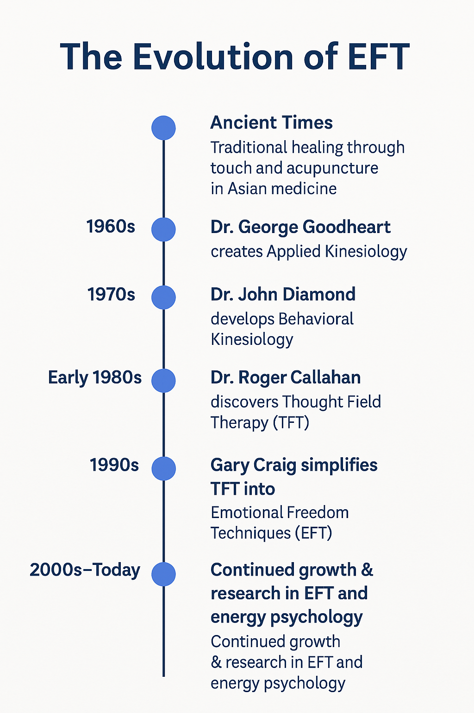
From Energy to Emotion
Building on this, psychiatrist Dr. John Diamond introduced Behavioral Kinesiology in the 1970s. He paired affirmations with acupoint stimulation to treat emotional and psychological issues — paving the way for what would become known as energy psychology.
A Serendipitous Discovery: Mary’s Story
In the early 1980s, psychologist Dr. Roger Callahan made a breakthrough while working with a patient named Mary, who had a debilitating phobia of water. She couldn’t bathe or approach a swimming pool without experiencing severe anxiety, despite two years of therapy.
One day, during a session, Mary mentioned that she felt her fear in her stomach. Dr. Callahan recalled that an acupuncture point just under the eye is linked to the stomach meridian. On a hunch, he asked her to tap gently beneath her eye while focusing on her fear.
What happened next was astonishing.
“It’s gone!” Mary exclaimed. Her lifelong terror of water had vanished.
Sceptical, Callahan followed her outside, where she ran to the swimming pool and began splashing her face with water — completely at ease. This spontaneous, seemingly permanent resolution of a long-standing phobia laid the foundation for a technique he called Thought Field Therapy (TFT).
Refining the Method: Enter EFT
In the 1990s, Gary Craig — a Stanford-trained engineer with a passion for personal growth — simplified TFT into a more accessible and consistent approach. He created Emotional Freedom Techniques (EFT), which combined tapping on specific points with focused attention on emotional issues. Craig emphasised that anyone could learn EFT, and its applications ranged from anxiety and cravings to pain relief and traumatic memories.
Why It Works
At its core, EFT rests on a key insight:
“The cause of all negative emotions is a disruption in the body’s energy system.” — Gary Craig
Much like acupuncture, EFT operates on the body’s meridian system. But instead of needles, EFT uses fingertip tapping to send calming signals to the brain. When done while tuned into a specific problem or memory, it helps restore energetic balance — often quickly, gently, and lastingly.
Gary Craig, The Creator of EFT writes,
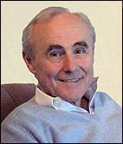
‘I have been intensely interested in personal improvement via psychology since my age 13. That was when I recognized that the quality of my thoughts was mirrored in the quality of my life. Since then, I have been self-taught in this field, seeking only those procedures that, in my opinion, produced results. EFT is my latest finding, the core of which I learned from Dr. Roger Callahan. I also have high regard for Neuro Linguistic Programming (NLP) in which I am a Certified Master Practitioner.’
‘I've been doing energy healing work since 1991 and my jaw still drops at the results. I've lost count of the number of phobias, panic/anxiety attacks, traumatic memories, guilt, grief and physical ailments that have been elegantly relieved (often in minutes) by this procedure. Even though EFT violates just about every conventional belief out there, the results remain remarkable. EFT isn't perfect, of course. We don't get 100%. But it usually works well and the results are sometimes spectacular. It often works where nothing else will.’
Gary Craig is neither a psychologist nor a licensed therapist. He is a Stanford engineer graduate who later became a dedicated student of A Course in Miracles. He approaches his work with a decidedly spiritual perspective. However, there is no specific spiritual teaching connected to EFT.
Ranjana’s personal experience: ‘I have been using EFT since 1999 as a self-help tool and began practicing EFT professionally since 2003. In my personal experience EFT has helped me overcome addictive behaviour patterns and manage anxiety and stress with calm. It has brought to my awareness experiences that have held me back. It has dramatically changed the way I live my life. In my practice I have witnessed hay fever symptoms vanish for good, infertility challenges shift, self-doubt and confusion be replaced by self-respect and self-confidence, physical pain diminish, chronic conditions become manageable, anxiety dramatically reduce, trauma heal and recurrent episodes of pain shift. EFT is a valuable tool that complements any therapy. However, I must point out that good nutrition; clean drinking water, movement and relaxation are vital for good health.’
Research
There have been many articles published online regarding EFT’s efficacy from anecdotal reports to randomised clinical trials.
It must be borne in mind that there are differing theories as to how EFT works. However, this doesn’t deter many medical/mental health professionals and complementary therapists from using EFT in their practice. Some of the reasons EFT is so widely used are:
- has been described as rapid, effective and gentle
- does not require hours of study to implement
- can be easily self-administered
- can be applied at anytime, anywhere
- does not require any equipment or medication
- is easily incorporated into your self-care regimen
- supports every healing modality
- doesn’t need a belief system to work
- and and and…

Recommended Reading
EFT (Emotional Freedom Techniques) comes under the umbrella of Energy Psychology. Energy psychology applies principles and techniques for working with the body’s physical energies to facilitate desired changes in emotions, thought, and behaviour. There is a wealth of research available at http://www.energypsych.org/?Research_Landing
David Feinstein’s article: Acupoint_Stimulation_Research_Review.pdf is a must read. http://energypsychotherapyworks.co.uk/wp-content/uploads/2013/05/Acupoint_Stimulation_Research_Review.pdf
The EFT research pages at https://eftinternational.org/discover-eft-tapping/eft-science-research/ are crammed full of empirical evidence.
What is EFT?
Emotional Freedom Techniques (EFT) has been described as being similar to gentle talk therapy with an added body component. Everyone can do it for themselves, and once you learn EFT, it's yours forever. Emotional Freedom Techniques, or EFT, incorporates psychological acupressure techniques that many doctors, healthcare and wellbeing professionals use in their practice to optimise emotional health. Professionals that include Candace Pert, Bruce Lipton, Debbie Ford, Dr. Phill Mollon, Deepak Chopra and many many more freely speak of EFT’s benefits. Although it is still often overlooked, emotional health is absolutely essential to your physical health and healing - no matter how devoted you are to the proper diet and lifestyle, it is more difficult to achieve your body's ideal healing and immune protective powers if stress or emotional barriers stand in your way.
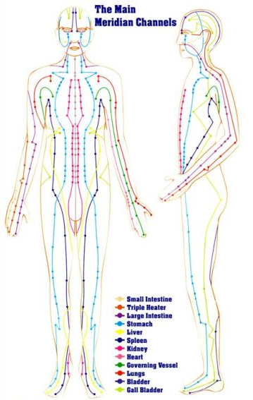
EFT is very easy to learn, and can help you:
- let go of negative emotions
- reduce food cravings
- manage pain
- heal trauma
- calm your nervous system
- implement positive goals
- break free from limiting beliefs
- develop Self Confidence
- and so much more

EFT has also been described as ‘psychological acupuncture’, it utilises the meridian system from traditional acupuncture to treat physical and emotional ailments without the invasiveness of needles. Instead, simple tapping with the fingertips is used to input kinetic energy onto specific meridians on the head, chest and fingers while you think about your specific problem - whether it is a traumatic event, an addiction, pain, etc. This combination of tapping the energy meridians and voicing the issue works to clear the ‘short-circuit’ - the emotional block -- from your body's bio energy system, thus restoring your mind and body's balance, which is essential for optimal health and healing.
As people experience EFT, they often report a profound easing of stress-producing emotions like anxiety and fear, anger and frustration, sadness, and even addictive cravings. EFT involves a simple process of tapping on stress-relief points; actually, acupuncture points, on the body as we talk about your issue. In this workshop you will learn to do the tapping yourself and ‘tap away' the negative emotional charge.
You may be aware that certain situations (people) upset you more than others. It's as if we have 'negative emotional wiring' programmed into us from prior experiences that act like stress triggers. EFT helps us ‘rewire’ the emotional patterns within us so that we are no longer disempowered or distressed by these triggers. EFT literally gives us 'emotional freedom' to feel different, lighter, less burdened by the past, less susceptible to reactivity.
EFT works in a complementary way with other therapies. For instance, someone who is processing issues with a talk therapist would benefit from the direct, body-centred emotional clearing offered by EFT individual sessions. EFT is also great for group work. You can often achieve your goals in a group setting with substantial savings. Another advantage of EFT is that sessions can be very successfully done over the phone or via video conferencing. You can experience this healing work in the convenience of your home and phone sessions can be more easily scheduled than office visits, especially if you live at a distance from your chosen EFT therapist.
The EFT Discovery Statement
The essence behind EFT is what Gary Craig refers to as the ‘Discovery Statement.’ The Discovery Statement is as follows:
The Cause of ALL Negative Emotions is a Disruption in the Body’s Energy System
Let's put this in terms of Mary's water phobia as dealt with by Callahan. When she was experiencing her fear, the energy flowing through her stomach meridian was disrupted. That energy imbalance is what was causing her emotional intensity. Tapping under her eyes sent pulses through the meridian and fixed the disruption. It balanced it out.
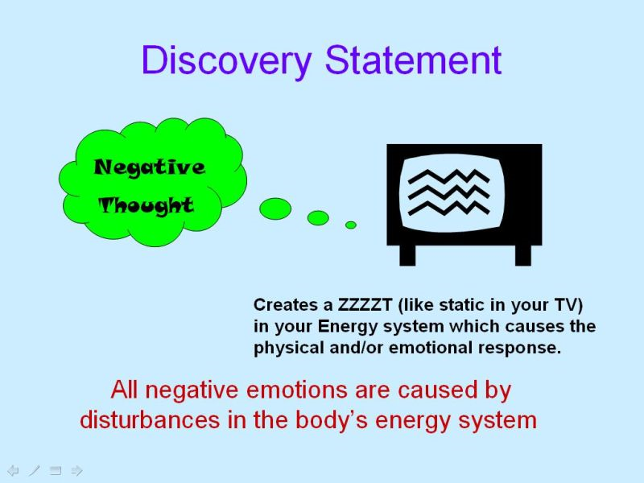
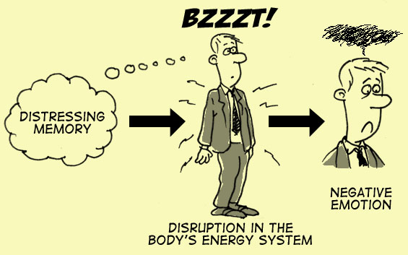
Once the energy meridian was balanced the emotional intensity.... the fear.... went away. In EFT unwanted emotions are caused by energy disruptions. Now, let's examine the discovery statement in more detail. First, notice what it does not say. It does not say that a negative emotion is caused by the memory of a past traumatic experience. This is important to recognize because it is easy to presume that one has to face traumatic memories to heal negative emotions, when actually negative emotions and their corresponding beliefs can shift once the energetic system has been balanced.
The underlying idea here is that you aren’t ‘mentally blocked’. Rather you are ‘energy blocked’. This refreshing way of viewing the human system suggests that an important factor in emotional problems can be found in the disruption of the subtle energies that are known to circulate throughout our bodies.
As Gary Craig neatly summarized in an article on his web site, all scientists agree that the body is an ‘energy configuration’ made up of positive and negative electrical charges in the form of atoms, the basic ‘building blocks of all matter.’ Einstein informed modern scientists that all matter lies somewhere on the same energy continuum. If we view the human body as an energy configuration rather than separate organs, parts and equations of chemicals, we will understand why and how EFT works. Therefore, clear the energy pathways of disruption and we experience harmony.
How does EFT work?
You balance your energy system while you are tuned in to the problem and thereby eliminate negative emotion (stress). Clear the energetic disruption, the stress (trauma) emotion clears and then memories can heal, beliefs can shift. This has a massive knock-on effect. By freeing energy that has been locked away we regain energy for creating positive change. EFT gives us the opportunity to heal from a place of peace. The negative emotional charge we carry, deny, or reject prevents healing. This charge is held energetically as a zzzzzzt. The tapping clears the zzzzzt and allows us recognise that we are safe, capable and we have the power to choose our responses in the present.
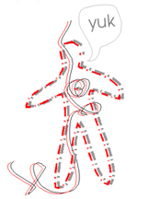  Hurt = Energy Disruption | 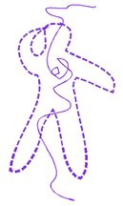  Using EFT |   Relief!
I am partial to Angela Treat Lyon’s description of this. She writes, ‘Here’s what happens. When we experience life's shocks, traumas and injuries, whether physical, emotional or mental - or all three - our body's energy system goes out of whack. We've incurred a shock, minor or major. Watch what happens when you kick a TV or a radio! According to its own sensitivity, it will now have a crack or a dent in its side, and the wiring is now askew.
What happens to us? We also get dents, bruises, breaks and ruptures - in our bodies, minds and feelings. Our ‘wires’ - the lines of natural energy that flow through our bodies, just as electricity flows through the earth - get crossed. Our wiring gets out of whack. We sustain energetic disruptions that run so deep we aren't even aware of them. We develop what are called limiting beliefs: ‘Oh, I hate swimming! The ocean is bad for you!’ For instance, at the age of three, a little girl might have been dunked by a wave and mama didn't come get her fast enough, so she built up a belief: ‘I'm afraid of the ocean.’ It turns into a phobia of water.
Or try this one: The office manager says, ‘I'm a failure. Everything I do turns into do-do.’ Whew! Is his wiring out or what? Someone probably told him in kindergarten that he was colouring wrong or that he was stupid or.... Can you see how that would hurt a little kid? What do you suppose happens to his ‘wiring?’
Rewiring Your System
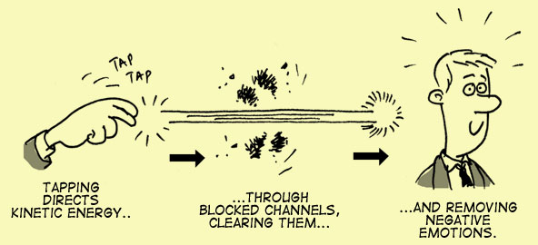
When you use the simple EFT tapping steps, you literally stimulate and change the ‘wiring’ in your body's energy system. You change its ability to function properly - just as you'd rewire that radio so it works right again. It's a little more complex than that, of course! The theory is that as you are treating at the energetic body it can balance and bring harmony to the mental-emotional and physical body.

Let’s Begin
Creating a space to use EFT with yourself and others
The first step before working with oneself or others is to create a safe space that is non-judgemental, accepting and understanding. Whether you are using EFT on yourself or with others the same rules apply. From now whether you are self-applying EFT or working with others we will use the term client to refer to the person receiving the treatment and practitioner to the person facilitating the treatment. The same applies when you are self-administering EFT as we recommend you take on both roles. Consider, what kind of environment you would like to create for yourself when you receive a treatment? Understanding the need to maintain confidentiality and having healthy boundaries are important for you and your client.
The Standard EFT International EFT Protocol
Most EFT International Trainers and Practitioners use this version of EFT. We will use this protocol throughout the training. This Standard EFT Protocol uses a “Setup” and a “Sequence of Tapping Points” that comprises one full round of EFT. This protocol aligns with EFT developer Gary Craig’s Gold Standard EFT protocol as well Peta Stapleton’s Clinical EFT.
THE STANDARD EFT PROTOCOL
1. Awareness: Tune into the problem, be specific notice any physical/ emotional mental stress, tension, suffering or pain. Note your Emotional Stress Intensity.
2. Compose/Create the Setup phrase and choose the Reminder phrase
A Setup example: ‘Even though I have this _______ for e.g. hideous headache… (This will become your Reminder phrase) ____ I deeply and completely accept myself.’
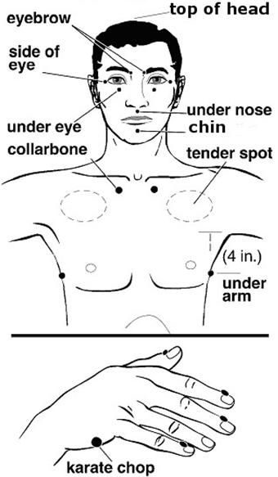
The Reminder phrase example: ‘this hideous headache’
3. Engage of the Body-Mind’s Healing Mechanism by Tapping or Rhythmic Touch. While continuously tapping the Side of Hand point or rubbing the Tender Spot repeat the Setup phrase 3 times. After completing the Setup tap about 7 times on each of the following energy points while repeating the Reminder phrase at each point.
Top of the head
Eyebrow
Side of eye
Under eye
Under nose
Chin
Collar bone
Under Arm
Thumb
Index Finger
Middle Finger
Ring Finger
Baby Finger

4. Scan, Measure and Test: Tune in again to the issue and notice any remaining intensity and proceed to tap yourself FREE. Drink water, breathe and test your results.
Note: In subsequent rounds The Setup affirmation and the Reminder phrase are adjusted to reflect the fact that you are addressing the remaining problem.

Step 1: Awareness and Intensity
Identify (tune into) the problem, be specific, notice any physical/emotional/mental stress, tension, suffering or pain. Problems are like puzzles and puzzles have a lot of pieces. The first step is to think about your problem and then pick the piece that you want to work on. When the piece of the problem is fixed you pick another piece until all the negative feelings are gone. (Be specific)
You might find closing your eyes and tuning in to the issue helpful. Take a measurement on a scale of 0-10 to gauge the intensity of the problem. You can ask, ‘What number would you give this problem on a scale of 1 to 10 where 10 is a very big problem and 1 is not big at all’. If you are tuning in to an emotion, ask ‘On a scale of 1 to 10 how intense is the feeling where 10 is very intense and 1 is not at all’. Alternatively, for physical tension, ask ‘On a scale of 1 to 10 what number would you give this tension where 10 is very high and 1 is not high at all’.
This value is known as either the ‘intensity level’ or SUDs (Subjective Units of Distress) level. In EFT we look to reducing this level to 0. It is not always possible as sometimes there will be other underlying problems and aspects that will need to be worked on. This is particularly true in the case of physical pain where there are often many emotional aspects that need to be addressed. We will look at this in more detail soon.
Step 2: Create/Compose the Setup Statement (phrase)
The basic formula for this is ‘Even though I have this (problem/issue) I deeply and completely accept myself.’
So, for example, if you had a headache you would say: ‘Even though I have this headache I deeply and completely accept myself’
The key to an effective Setup phrase is to be as specific as possible. While you can work on more general issues they take much longer. Focusing on an exact time/event/emotion and naming anyone involved will help you get quicker and more effective results. With time you will learn to develop Setups that target the problem very quickly. When working on physical pain try to name its location and describe its feeling, e.g. 'this throbbing pain just behind my left eye'. The positive affirmation used at the end of the Setup phrase helps neutralise the negative effects of the issue, making it easy to resolve/transform.
Step 3: Engage the Body-Mind and do the EFT Sequence with the Setup and Reminder Phrase
The Reminder phrase is a shortened version of the Setup phrase used to help you remain focused on the problem and prevent the mind from wandering. So, in the example of a headache the Reminder phrase would simply be ‘this headache’. In a more complicated Setup with a long description such as, 'this sharp shooting pain up the side of my left leg whenever I try to bend over', you can either repeat the whole phrase, or abbreviate it. Simply shortening it to 'sharp shooting pain' will still work for most people; the important point is to remain focused on where you feel the pain.
Step 4: Scan and Asses - Measuring and Testing Intensity (SUD’s)
Tune in to the issue and notice any remaining intensity. Let's say you are using this Sequence for some problem (fear, headache, anger, etc.). Sometimes the problem will simply vanish after just one round while, at other times, one round provides only partial relief. When only partial relief is obtained, you will need to do one or more additional rounds. Repeat the steps again to clear other pieces of the puzzle and any remaining upset. Persist lovingly and let the core issue surface.
Measuring and Testing are both critical for knowing where you’ve started, when you’re done or how much is left to do. Measuring helps the client tune into their issue (before the tapping) and reveals how Intensity Levels may rise even as the client tunes in to the issue/problem/event (i.e. Sometimes it gets worse before it gets better). There are different ways/types of measuring emotional intensity for example with colour, temperature, sound, texture and so on. Changes in emotional intensity can be expressed in many ways for example, yawning, physical, relaxation, and sighing. Once a client expresses relief you need to test your work, tune in, use real experience or by imagining the challenging situation. Testing reveals whether the work is done or not.

Adjustments for Subsequent Rounds
Subsequent rounds now need to be adjusted for best results. Since the subconscious mind tends to be very literal, the subsequent rounds need to address the fact that you are working on the remaining problem. Accordingly, the affirmation contained within the Setup needs to be adjusted, as does the Reminder phrase. Here's an adjusted format for The Setup:
Even though I still have some of this __________, I deeply and completely accept myself. Please note the emphasized words (still & some) and how they change the thrust of the statement towards the remainder of the problem. It should be easy to make this adjustment, and, after a little experience, you will fall into it quite naturally.
Summarising A Session
Start by identifying the problem. Note your intensity level and then create a Setup statement and choose the Reminder phrase. Do the tapping sequence and complete this with another round of tapping using the Reminder phrase. Once you have done a round, stop, close your eyes and re-evaluate the problem. If there is still some excess emotion or tension do another round. This time though change the Setup phrase to start with, ‘Even though I have this remaining ………. So, for the example of the headache it would become: ‘Even though I have this remaining headache, I deeply and completely accept myself’ Keep measuring, testing and repeating rounds until the problem has resolved.
The Original EFT Sequence and the Gamut Point
Start by repeating the Setup phrase 3 times while rubbing the Sore Spot or the Side of Hand (aka Karate Chop) point. Then repeat the Reminder phrase while tapping with 2 or 3 fingers about 7 times on each of the other points. Start at the Top of the Head point and work down Eyebrow, Side of eye, Under eye, Under nose, Chin, Collar bone and Under Arm. You can then continue tapping on the Thumb, Index Finger, Middle Finger, Baby Finger, finishing at the Side of Hand point, missing out the sore spots and the gamut point. Tapping should be firm but not too hard as to hurt or cause injury. It can be done on either side of the body, as points are bilateral. Use whichever side feels most comfortable or swap from side to side.
The 9 Gamut Procedure
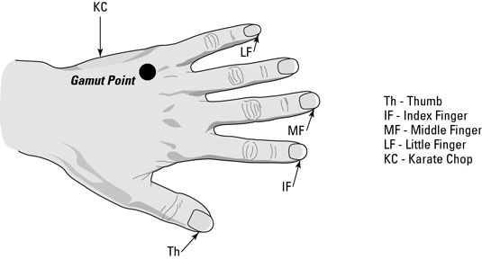
This is perhaps one of the strangest parts of EFT. It is basically a brain balancing exercise, which has the added effect of cutting through mental or emotional conflict. There are 9 stages to the sequence that are all carried out while tapping the gamut point and trying to remain focused on the problem, they are:
- Shut Eyes, Open Eyes
- Look hard down right, then hard down left
- Roll eyes around clockwise, and then counter clockwise
- Hum a tune for 5 seconds
- Count to 5
- Again, hum for 5 seconds
The 9 Gamut acts as a brain balancer. You may have an understanding of the function of the left and right hemispheres of the brain. Lay people know that one side is creative and the other side more logical and rational. This knowledge can often be a very effective bridge in explaining how EFT and particularly the 9 Gamut Procedure work. The gamut procedure also meshes very well with the NLP eye accessing cues explanation on information processing. In addition to this, clients who come for therapy, especially professional health care workers frequently know of the effectiveness of EMDR.
Next return to the Sequence using the ‘reminder phrase’ and then measure and test your work.
A Few Notes:
You can use the side of hand point instead of the sore spot (tender spot) for the Setup phrase at the beginning of each round, check what works for you. If you are experiencing intense emotions (crisis emotion or an emotional hijack) the Setup and Reminder phrases can be dropped. Simply tap on the meridian points until you feel calm. The purpose of the Setup and the Reminder phrase is to help you to tune-in. When you are experiencing or noticing an intense emotional response then you are already tuned in and do not need to articulate the issue.
You can leave out the 9-gamut procedure, using it only when a client gets stuck. Leaving out the points on the fingers also seems to be fine. In most cases going straight to the side of hand point after doing the face and body works just as well as the full sequence, another 20 seconds saved. Some practitioners prefer to keep the finger points in for effectiveness, and it takes so little time. Our advice is experiment and sees what works for you. Trust your intuition.
If You Get Stuck
Sometimes you might not seem to be making any progress. If this is the case then you might try one of the following to help:
- Try a different Setup phrase.
- Make sure you are being as specific as possible.
- Drink a glass of water, this helps move things and may give insight.
- Move around, some gentle exercise may help shift whatever is stuck.
- Book a session with a qualified EFT International Practitioner
Things to Remember about EFT
- EFT does not remove your common sense
- Does not replace rational trepidation or other normal emotions…. it merely removes the excess
- Does not make you an emotional robot
- Does not replace correct medical supervision

You May Experience…
During an EFT session, any or all of the following sensations may be experienced – all which are perfectly normal and natural:
- Desire to yawn, burp or sneeze
- Tingling sensation
- Tightness in parts of the body
- Emotional (sad, angry etc.)
- Feeling hot or cold
- Feeling light headed/spaced out
- Shaking
- Coughing
- Abreaction (Intense physical and emotional response)

Getting it Right
With EFT this is relatively easy to do. You can tap on either side of the body, or both sides of the body, in any order, or stay on one point. But here are some important foundational must do’s:
Be Specific:
Identify the issue; break it down into bite sized chunks, make it easy for yourself by targeting your tapping. This is one of the hardest things to do in the beginning. Many people see their issues in a global context, their problems are all-encompassing, ‘I am anxious all the time’, ‘My body hurts’, ‘I was abused’, ‘I am stuck’… By tuning in, ‘How do you know you are anxious? Where do you experience pain? When were you abused? Where in your life do you feel stuck the most?’ With EFT you can dismantle the issue, uncover aspects and clear the zzzzzzt.
Mirror the Words AND Feel the Words
It is best to use language and words that ‘tell it as it is’. Use the client’s words exactly as they show up, this will help you build rapport and empower the client so that they are leading the session. Cleaned up, translated, or interpreted (imposed) vocabulary slows the process. Use your client’s exact words. Use words that help the tuning in process. Use opening (tuned in to the issue) and affirmative (balancing) phrases that resonate. Listening and reflecting a client’s subjective experience is foundational for developing and maintaining rapport. Change the Setup phrase to reflect how the client really feels, make sure that the affirmation you use lands. Sometimes you may need to get the client to say the phrase aloud with feeling.
The Issue ‘Even though | Affirmation
…I am afraid of the sound of his voice…. | …I accept my fear; I am OK now’
…I am worried about meeting her for the first time…. | ….and I acknowledge my sweaty palms’
…I am furious and disappointed about…. | …. I want to let it go’
…. speaking up fills me with dread | …. I’m doing the best I can’

Notice the many ‘Triggers’ that effect emotion, behaviour or beliefs. These will direct you in creating effective Setup phrases.
Senses: what you see, hear, or smell
‘Even though the smell of roses reminds me of my mother, I truly and deeply accept myself.’ ‘Even though the sound of that music makes me sad, I accept my sadness.’
Emotions: anger, sadness, fear
‘Even though I’m angry because that driver didn’t stop, I accept myself anyway.’
Physical: heart racing, legs shaking,
‘Even though my legs shake when I go into that meeting, I deeply accept who I am.’
Behaviour: want to run away, need to hide
‘Even though I want to run away when I see that man, I would like to feel strong.’
Belief
‘Even though I believe I am not good enough, I want to accept myself one day.’
The Setup phrase allows you to focus on the problem and put it into perspective. It gives you permission to acknowledge your issue, release the resistance to healing and open to change.
Persistence Pays
Tapping systematically through issues reducing intensity methodically will pave the way for success. Addressing all intense aspects of an issue (emotional, mental, physical, etc.) will maximize results. Tap regularly and frequently
Hydration
There is now a lot of research on how dehydration impacts our cognitive functions. We need to drink water. Please be sure to keep your body well hydrated. Emotional Freedom Techniques and other energy therapies work with the electricity of your body, and water conducts electricity. It is very important to drink water to flush out any toxins that get released. 70% of our bodies are composed of water –drinking water is vital to our health and vitality.
Handling Excessive Emotional Intensity
There are going to be times when as part of the process, the client releases pent-up emotion, when this happens simply continue to tap through all the meridian points until they feel calm.

Becoming an EFT Detective
Asking Questions

Asking the right questions at the right time is essential to zeroing in on the exact issue you are working on. Listening deeply to the answers to these questions separates good EFT practitioners from excellent, masterful ones. Good Questions help you get specific.
A brilliant question of course is Gary Craig’s ‘If you could live your life over again, and there was something or someone in your life you would just as soon skip, what or who would it be?’ This gives the therapist immediate access to troublesome memories, relationships, and time periods in the client’s life that the client might not have associated with their emotional conflicts or physical ailments. Here are some useful questions:
- How long have you suffered from this problem (conflict, ailment, disorder, and concern.)
- What was happening in your life before or during the time of diagnosis, or when you noticed this problem arise?
- What does this issue remind you of? If there was a deeper emotion underlying this problem, what might it be?
- How would you feel if you didn’t have this in your life?
- What is YOUR theory about why you haven’t yet resolved this dilemma, cleared this issue, and neutralized this conflict?

In the Level 2 Training we learn more about asking the right questions and dealing with complex projects. Asking the good questions will save you time and it will improve your success rate. Continue asking questions that will reveal the heart of your client’s issues, and your success with EFT will rise dramatically. Good questions, listening, paying attention, tapping methodically will help you uncover aspects that hold core issues in place.
Understanding how aspects work will enhance your EFT practice.

Aspects
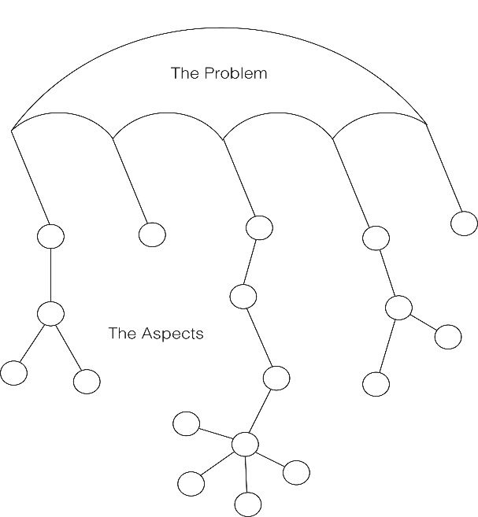
Most problems have multiple aspects. It is important to work through as many aspects one at a time, until the issue dissolves. Each aspect is a separate tappable issue. However, many people don't usually make this distinction unless you point it out to them. Suppose, for example, a family member wants help with their frightful memories regarding an automobile accident. You can apply EFT, of course, to ‘this accident’ and you are likely to make good progress. If you don't, however, you can ask for more specifics (aspects) with a question like...
‘What about the accident bothers you the most?’
Let's suppose they say, ‘Oh, the headlights, the headlights, I can still see them coming at me!’ You can then tap on ‘the headlights’ or ‘my fear of the headlights or any other description that seems to fit. After the client's reaction to the headlights has been EFT'd to zero, you can then ask...
‘What else about the accident bothers you?’
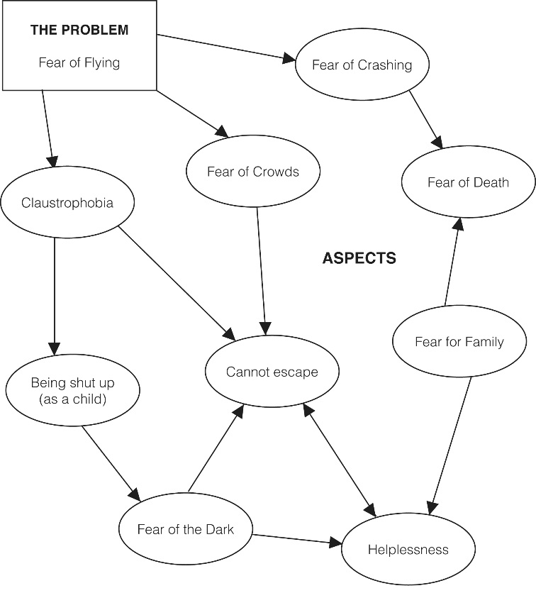
At this point the client may bring up other aspects such as, ‘The screams in the car’ or ‘My anger at the other driver’ or ‘My anger at the doctors,’ etc. The list can be quite long. Usually, though, events contain only a few emotionally charged (energetically disrupted) aspects. Tap on all the aspects until the client can no longer find anything bothersome about the accident.
As a test, ask them to ‘run the movie’ of the accident in their mind in vivid detail. This will bring up any trailing aspects for tapping. Eventually, the client should have no charge on the accident. It will just be an unfortunate event in their life--and that's all.
One mistake that is often made along the way, however, is to tap on ‘the headlights’ and then ask a much too global question such as, ‘How do you feel about the accident now?’ That question doesn't ask for any new aspects. It just asks for an overall feeling. In fact, if there are any other aspects (such as ‘the screams in the car’) the client will report ‘no progress’ because they still have intensity. Remember, the client doesn't distinguish between the aspects. To them, it's all one big problem. You have to make the distinction by first recognizing that aspects exist (that's just simply experience) and, second, asking the right questions to bring them to the surface.
Being specific and getting to all the aspects is vital for the results of EFT to be lasting. The problem is that most newcomers to EFT tend to see their issues through ‘global glasses.’ That is, they describe their issues using broad labels which, to them, seem very specific. Examples might be...
‘I just don't feel very good about myself.’
‘My father always abused me.’
‘My mother never gave me the love I should have had.’
‘I don't do very well with relationships.’
‘I'm easily rejected.’

Each of these...and countless more like them...are like emotional walls made up of specific bricks and stones (negative events) which contribute to the overall problem. Using EFT on the globally stated problem is like trying to bulldoze an entire wall with a small hammer. If you address the global problem in this way, you will probably make some progress each time you tap. However, compared to the enormity of the wall, the progress is not likely to be noticed and thus the client will probably claim ‘no result’...or...you might erroneously consider them resistant to healing, ...or you might erroneously conclude that they are beset with energy toxins...or...you might give up and think EFT ‘doesn't work’ or...or...or. Asking open investigative questions are key to uncovering aspects.
Instead of using EFT on an issue like, ‘Even though I'm easily rejected.....’ it is best to break down the globally stated problem into specific events such as....
‘Even though my 3rd grade teacher embarrassed me in front of the class.....’
‘Even though I felt so left out when my father didn't attend my high school graduation....’
‘Even though I was sent to my room for the whole day on Christmas at age 8....’
‘Even though Mom told me 'you'll never get married unless you are thin like your sister'....’

These are the TRUE CONTRIBUTORS to the ‘I'm easily rejected’ issue. They represent the FOUNDATION of the problem. The feeling of rejection is but the symptom of these underlying specific causes. Stated differently, if we didn't have these specific causes, how could we possibly feel rejection? The answer is 'we couldn't' because there would be no prior experience by which to measure a current ‘rejection.’ We need to neutralize these causes by using EFT on individual aspects. When we do, several benefits occur....
1. You can easily recognize when EFT has eliminated a negative event from their wall. They may start with an intensity of 7-10 for a given event and end with an intensity of 0. This is clearly noticeable and thus substantially improves the client's (and your) confidence in the method.
2. Each brick that is removed weakens the wall. This allows the client to see through the wall with ease instead of constantly bumping into yet another ‘rejection brick.’ The sting of rejection reduces systematically.
3. An important Generalization Effect occurs. The various ‘rejection bricks’ tend to have some common themes among them so that removing one brick has an effect on the remaining wall. Often, we can remove 5 or10 bricks and then watch the whole wall fall.
When working with aspects work with the aspect that is most present for the client; for example, the one that has the highest emotional charge. As the SUDs of the original aspect lowers move to the next aspect. Sometimes you will notice aspects are inter-related. Never assume you know your client’s aspects. Work with their aspects using their words at the pace they are comfortable. An aspect can be an emotion, event, belief or physical sensation. At the end of each round, check the intensity of the aspect and see if there have been any changes either positive or negative. Aspects can also show up as resistance to healing – as psychological reversal.

The Concept of Psychological Reversal (Psychological Resistance) Also known as Resistance to Healing
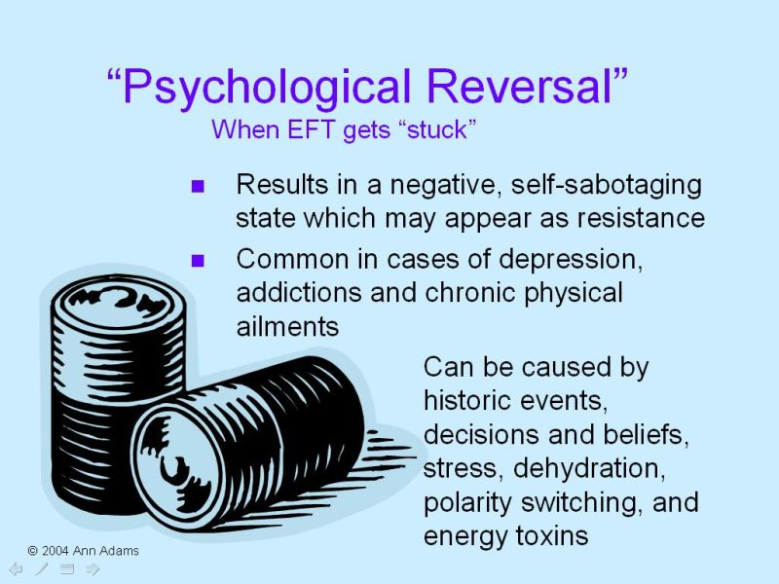
The concept of Psychological Reversal (PR) as a barrier to EFT success has been an important part of EFT’s development (history). Although it is no longer required study and the concept is no longer taught by EFT Developer Gary Craig. It still has some merit. Psychological reversal (PR) was described as a sub-conscious block to EFT that can come and go. It can occur when the energy flow becomes reversed and nothing seems to work. Just like when batteries are placed the wrong way round and equipment will not work. It can show up in many ways. Many experienced practitioners describe it as self-sabotage or secondary gain - best handled as separate aspects. The Setup phrase was designed to handle any conflict in the person’s energy system or subconscious resistance to the EFT process.
The principle of Psychological Reversal (PR) is that if your natural energy flow becomes ‘reversed’ due to shock, stress, or trauma, healing cannot take place easily as the body is fighting against the natural healing process. This may be entirely unconscious, or, you may be aware that you have a fear of getting over the problem, a fear you will not get over the problem, a feeling you don’t deserve to get over it, or even a feeling that it is not safe to get over it. Resistance/Reversal is almost always at the root of the problem when people ‘don’t want to get better’, or that those suffering from depression, anxiety, weight or addiction problems, especially when you hear yourself say, ‘I just have no will power’. In such cases EFT corrects psychological reversal and opens new possibilities for recovery and healing. Once psychological reversal has been addressed successfully with EFT, other healing modalities that had previously little or no impact on the problem can also become effective.
Take for example somebody who wants to quit smoking. They still have some deeper part of them that wants to carry on smoking. Finding these different aspects and treating them with the help of the Setup phrase, can correct this reversal/resistance. The outcome of this is it’s possible to help someone to stop when his or her will power is not strong enough. In fact it even demonstrates that will power is not always enough to overcome addictions. Will power if used for long durations is another form of stress on the body. It is great to use in emergency situations, but if used to overcome a craving it is likely that the craving will resurface for something else. This is commonly seen when someone quits smoking and starts eating more instead. (This is covered in depth at the EFT Level 2 training)
PR correction is built into the EFT protocol by rubbing the sore spot or tapping on the side of hand point. If the client is tuned into the issue and is not reversed then Setup is not necessary, but as a general rule it is quicker to use the setup than it is to test for reversal, so we almost always use the Setup.
You may notice that experienced practitioners do not always use the Setup, especially after the first tapping round. This is because they are confident that PR (resistance) is not a factor, the client is tuned in and the energy system is balancing. It is efficient and effective to use the Setup in the initial round of tapping.
When EFT doesn’t work
Sometimes you might not seem to be making any progress. If this is the case then you might try one of the following to help:
- Try a different Setup phrase.
- Make sure you are being as specific as possible.
- Watch for shifting aspects and psychological resistance
- Drink a glass of water, this helps move things and may give insight.
- Move around, some gentle exercise may help shift whatever is stuck.
- Say the Setup and reminder phrases forcefully, exaggerate the wording, ‘this really, really terrible headache’.
- Do the basic recipe while looking in the mirror.

And When EFT does Work… The Generalisation Effect
After you have used EFT to neutralize aspects, specific events, emotions or a certain distressing issue, the positive effects tend to generalize across associated issues. This is because many of our challenging memories and problems have commonalities.
For example, someone who has 20 traumatic memories usually finds that after using EFT for a few them, the intensities tend to diminish for all of them. Working on the most significant memory, usually the earliest, tends to offer the best results.
Cognitive Shifts and the Apex Effect
After EFT, a cognitive shift can take place that can leave the person wondering what the problem was. They then find it hard to believe, and in some cases just don’t even remember, that they had a problem. This is known as the Apex effect. This is further heightened by the general disbelief that this technique could work. For that reason, it is important to write down whatever you are treating and its intensity level before starting.
We ask you to consciously note your issues before you begin EFT, because, unless you do, the quality healing you will have undergone will seem so subtle that you may not notice it. You may even dismiss it saying, ‘Oh well, it was never much of a problem anyway.’ This happens repeatedly with EFT.
Most people reach into their own bag of knowledge and experience and link what just happened to what they already ‘know’ to be true. EFT isn't in that bag (yet) and so they have difficulty making the link. Now we know how scientists of several centuries ago felt when they tried to tell flat earth believers that the world was round.
Explanations we have come across while demonstrating EFT are numerous, my favorite and most common one is being told that the tapping techniques were distractions that took people's minds off their problems. This ignores the requirement that people ‘tune in’ to their problem for EFT to work. It is the exact opposite of distraction.
Hardly ever does anyone say, ‘Oh...it's like you said. You balanced the energy system while they were tuned in to the problem and thereby eliminated the cause.’ Yet that is what happened. Often even the people making the changes will credit something else for creating the change. They aren't able to link it to the tapping techniques. To them it doesn't compute. It doesn't make sense. There must be some other explanation. It is not to be criticized. But it is important to observe and understand because it does happen with great frequency.
Continual Tapping and Your Point
Continual Tapping is something I have used since I first discovered EFT in 1999. Having experimented with continual tapping for years, I have found that the increased meridian stimulation produces excellent results in sessions and for those using it at home. I routinely have clients tapping for most of the therapy session.
Dr. David Lake documented the use of continual tapping in relation to treating trauma. He recounts how he came upon the idea: ‘In the early days I would do a lot of talking about the problem with the client and then we would work through their traumatic incident(s) using EFT. We would typically get through about 10 – 12 rounds of EFT in a 1-hour session with a lot of talking in between. Later as I got more efficient, we would get through say 15 rounds of EFT in a session. I noticed that the results were better for clients in those sessions where we had done more rounds of tapping so I thought ‘Why stop? Why not continue tapping throughout the session?’ I started doing so, having the client tap not only while relating the story, while talking about the problem, and also while processing what happened – basically the whole time during the session. My results improved accordingly.’
You can also practise continual tapping by tapping on all of the fingers using the thumb of the same hand. Tapping on the finger points in this way (i.e. using the thumb of the same hand) can be done while watching TV, talking on the phone, while walking, among other things, and is also a very unobtrusive form of tapping that can be done in public. This technique is also used in other energy healing traditions. In experimenting with this process I found that tapping continually on the energy points can alleviate even those problems that haven’t been tapped on specifically – i.e. when the person doing the tapping has not focused specifically on those issues during the tapping process. The practice of continual tapping seems to have the effect of ‘toning’ the energy system in a beneficial way such that many emotional problems can release their hold – even without having been the specific target of the tapping process.

Continual Tapping for Self-Help:
1. Focus on any emotional or physical problem and simply tap on any of the points in any order until you feel relief. If you prefer you can rub or hold the points - Just get some meridian stimulation happening. The actual sequence you use doesn’t matter all that much, although it does seem necessary to include at least 3-4 different meridian points in the sequence.
2. Even when you aren’t specifically focusing in on the problem, just tap on the points continually. This appears to have the beneficial effect of ‘toning’ your energy system. It works even if you are not actually concentrating directly (although directly is ideal), or you don’t know consciously what the problem is. Part of you does know.
3. Get some meridian stimulation into your day wherever possible without always worrying about having to say or do anything specific. Most people who do this on a daily practice report that their optimism and positive energy levels increase over time and their general stress levels decrease. We now believe that enough meridian stimulation may cause a shift in your nervous system such that your negative problems cannot take hold in the same way.
4. We recommend linking continual tapping to other habits such as watching TV, talking on the phone, or going for a walk (see notes above on finger tapping for an easy way to do the tapping on a regular basis – and in public). Make it a beneficial habit.
5. Don’t just wait for a problem to arise to start tapping. By tapping on a more continual basis, you will be increasing your positive energy and decreasing your stress levels automatically.
6. It is fine to also do focus sessions where you aim to specifically identify the aspects of your problem and apply energy stimulation (tapping or rubbing or holding the points) to them. Consider working with someone else if you have trouble identifying parts of the problem to work on. In the meantime, continual tapping without specific focusing can still be beneficial.
7. Let your thoughts and feelings come while you tap. Accept every thought and feeling and allow even negative thoughts to come but add tapping to their presence.
8. Take a deep breath after a sequence of tapping, or when you notice a 'shift'.
9. Be yourself while tapping and increase your self-acceptance.
10. Tap to allow your 'bodymind' to function smoothly, without thinking.
Be willing to consult a professional therapist or physician for more complex issues that don’t shift, and especially for undiagnosed physical issues.
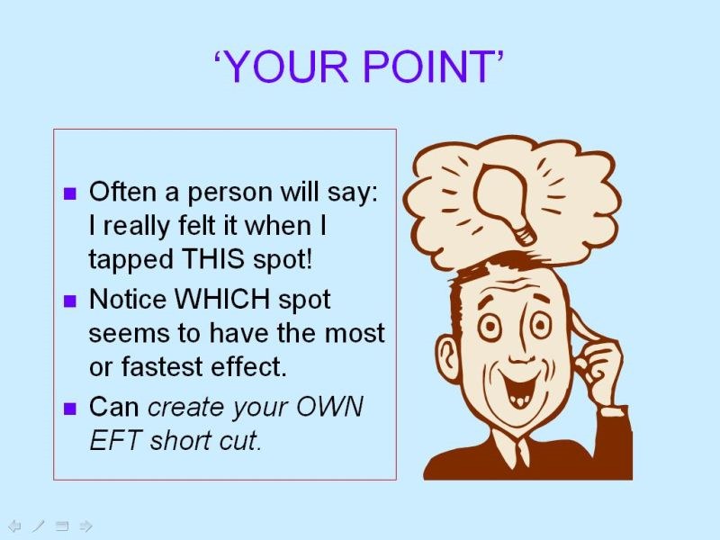
Another great Self-Help is Discovering Your Point.
While tapping you may notice that a particular meridian point really helps you release faster. Tapping on this point regularly will help increase your success with EFT.

Borrowing Benefits
Borrowing Benefits allows someone with little or no experience in EFT to tap along while someone else who is undergoing EFT (e.g. in a session, seminar, group or video) and experience profound benefits. This is true even though the issues being tapped on appear to be widely different.

Introduction to Working with Memory and Trauma
The Narrated Movie Technique (The Movie Technique and Tell the Story Technique)
The Movie Technique
EFT can be used to disarm the effects of troubling memories. Researchers understand that trauma affects us on many levels and if left untreated can lead to physical, mental and emotional stress. Working with memory and trauma with EFT requires care, attention and expertise. If in doubt refer your client to a more experienced practitioner.
If done correctly The Movie Technique can gently disarm and resolve the effects of traumatic events. Here are the steps:
1. Identify a short uncomfortable event (less than 2 minutes) that includes an emotional crescendo – something specific that happened, that you can picture in your mind.
Consider a traumatic memory as a short movie that runs in the theatre of your mind. There is a beginning. There are main characters and events. And there is an end. Usually, the ‘movie’ plays in a flash and ends in a familiar unwanted emotion. Because the movie plays so fast, we are unaware that it may have different aspects that are contributing to the negative emotion. It seems to come from the movie as a whole.
2. Give the scene a title, measure the intensity and tap the title as low as it will go, until you are ready to narrate the scene.
If you can run the movie in slow motion in your mind’s eye, the different aspects could be located and then addressed.
3. Tap through each crescendo of intensity (tapping each one to <2 intensity) working through any aspects that show up.
4. Narrate the movie to test your work, stop to tap on any remaining intensity.
The best way to do this is to narrate the movie OUT LOUD. Tell it to a friend, or a mirror or a tape recorder. And, most importantly, tell it in detail. This automatically slows the movie down because words are much slower than thoughts. When recounting a past event, start at the beginning.
As you tell it in detail, each aspect will make itself known to you. Stop as soon as you feel any intensity. It is also important to remain observant of any visual or auditory clues of emotional stress. Now treat whatever is happening at this point until the intensity level reaches a 0. Now repeat the story from the beginning, again stopping at the first signs of emotional stress. Keep doing this until the whole event can be recounted without upset. This technique is useful to ensure all aspects of a trauma are treated. It also allows you to work through an issue without being overwhelmed by feelings. Often in doing this, other memories will surface and these too may be later treated if needed. It is important to go slowly and be thorough.
This Technique is also known as Tell the Story Technique
Another similar method is called Tell the Story
1. Give the story a name and scale the intensity. Notice the emotion associated with the story, measure the discomfort when the memory is recalled.
2. Complete a round of tapping and bring the SUDs to a manageable level
3. When the intensity comes down have the client tell their story of the event/memory/trigger.
4. As soon as any emotional disturbance is detected, stop and measure the emotion. Then tap using the client’s specific words to bring down the intensity of the emotion.
5. Test by having the client re-tell the part of the story with the emotional intensity. They should be able to go past the previous emotional point easily. If not, there are further aspects to be addressed.
6. When the client is calm have them continue to tell the story.
7. Stop and tap on each emotional disturbance (crescendo). Measure the emotion, tap using the client’s words. If the intensity comes down test it by re-telling the story from the start to that point.
8. Test by asking your client to tell the entire story from start to finish
9. It is complete when your client can tell the story and remain calm throughout.

In order to process well, we need to focus on and fully accept the inner pictures, sounds and feelings that arise.
Sometimes things ‘come up’ which may seem ugly, ‘bad’, unhelpful, or even revolting. The correct approach is one of respect. Pushing away or rejecting parts of our memories or ourselves works against the process.
EFT for Physical Issues
EFT can be used to address physical issues. Curious questions like, ‘Where does it hurt?’ or ‘What does the pain feel like?’ will help you uncover specific aspects.
Here are some more useful questions:
- When did it begin?
- What was going on in your life around that time?
- What does the pain remind you of?
- Describe exactly where it is. ‘Right shoulder blade’
- Use their exact words. So if they say ‘this aggravating bursitis’ or ‘angry red pain’ you use those words
- How they describe it. Not just ‘this knee pain’ but ‘this throbbing pain in the back of my left knee’.
- What kind of ‘ache’ is it?
- Is there an emotion attached to this symptom?
- How does the pain make you feel?
- What triggers it off?
- How do you want to feel or what do you want to be able to do?
- Who is the pain in your life?
It will also be useful to explore the history of the issue by asking questions like, ‘What was going on in your life when this first started?’
After EFT, notice if there is a shift, has the intensity changed:
- Is it worse or better?
- Has it changed in nature or quality?
- Has it changed its location?
Following the changing location of pain is known as ‘chasing the pain’. Track the most intense aspects of pain/discomfort as they move around the body, tuning into the quality of the discomfort while using EFT. Repeat until the tension releases.
EFT for Cravings
When our emotional needs are not met, it’s human nature to seek comfort in other ways in order to ‘self -medicate’ or ‘self soothe’. These comforting habits can become addictive and difficult to stop. EFT can work on cravings and addictions but it does take persistence and often requires searching for the underlying cause. When did the obsessive behaviour start? What was going on in their life at the time? When do they need to carry out the behaviour?
Common addictions include addictions to alcohol or drugs, but it is possible to become addicted to anything, from gambling to sex to chocolate. You cannot control how you use whatever you are addicted to, and you become dependent on it to get through daily life.
Studies have shown low serotine levels can be linked to addictive behaviours. While at the surface the addictive substance helps to tranquilise the underlying anxiety of uneasiness there is usually low self-esteem at a deeper level. By taking the addictive substance, it may numb out the underlying emotions, such as loneliness, sadness, anger, stress, worry, fear, guilt as well as hurt. Sometimes it is easier to numb out the emotional pain then to work through it.
EFT can be used release the symptoms as well as get to and clear the root cause of addictions. There are many different layers to additions. At the surface there is anxiety or stress. An urge to smoke, for example, can be a reminder to breathe deeply (this may be the only time someone actually takes full breaths). An overwhelming anxiety may, in fact, be trying to keep someone safe, or telling them to stand up for themselves or to spend time in peaceful solitude. Underneath the anxiety there can be negative emotions that are too painful. Studies have also shown 80% of addictions can have a root in some of form of trauma or emotional upset earlier in life.
Sometimes the substance is a substitute for something that is missing – comfort, safety, love, protection. Ask ‘How does the substance make you feel when you take it?’, then ‘When was this feeling missing in your life?’, ‘How does that make you feel?’, ‘How old were you and that was going on?
Related Areas for EFT
Addictive Cravings
A good starting point in working with addictions is the experience of needing the behaviour or substance. Ask ‘What does it feel like when you have a craving?’ ‘Can you get that feeling now?’ and then do a few rounds of EFT. Ask them ‘Will that feeling still come back?’ Teach them how to do EFT for themselves and suggest they repeat the tapping every hour for the next few days.
Beliefs and Capabilities
I can’t manage without XXXXX
My life won’t be worth living without XXXX
I don’t believe this will work
I’ll lose my friends if I give XXXX up
Triggers
‘When do you most want that?’ ‘Where are you when you get tempted?’ Do several rounds of EFT on whatever the main triggers are and have them vividly imagine being in that situation.
Memories and Trauma
Ask when the behaviour started and what was going on in their lives then. What started as a way of coping with difficult times may now persist as a bad habit.
Future Anxieties
If behaviour has persisted for some time the person cannot see a future without it. Look for blocking beliefs such as ‘It’s not safe for me to get better’. Tap on their doubts, fears and uncertainties and help them to see that they are creating their own future. Can they imagine themselves free of the addictive substance/behaviour?
Resistance
Resistance and/or reversal are almost always present with addictions. If a craving comes back, it’s because the underlying emotional aspect hasn’t been cleared. The more EFT is used on the craving, the weaker the urge becomes and the longer it takes to return.
REMEMBER... tap when you are experiencing the craving.
An Outline for using EFT for Cravings
1. Rate your urge or the intensity of the craving, on a scale of 0 to 10. Example: I feel like having a piece of cake at an intensity of 8 (0 = I do not crave having a piece of cake at all and 10 = I desperately want to have a piece of cake!)
Make sure you fully associate with the food, snack item or beverage. Locate the feeling or sensation in your body associated with this craving. Think about the item you are craving, get a mental picture and imagine it in detail, think about its aroma, its texture i.e. how it would feel in your mouth. Go into as much detail as possible. Include what it reminds you of if it helps.
2. Start with the Setup. ‘Even though I have this ___ craving in my ____ (area in body where you feel the craving i.e. mouth, stomach etc.), it makes me feel ____. I deeply and completely accept myself.’
3. Now use the EFT Sequence
4. Rate your craving intensity again (i.e. check the sensation in your body associated with the craving). If it is greater than a 2 (i.e. 3 to 10) do another round of tapping while adjusting the Setup and Reminder phrase.
If SUDs are not shifting…
- Introduce the Finger Points and the 9 Gamut.
- Ask how they feel when they can’t have the item
- Introduce the questions as above
- Work on the earliest memory associated with the craving

EFT for Phobias
EFT can also be used to address phobias. Curious questions like, ‘When did you first notice this fear?’ or ‘Where do experience the phobia in your body?’ will help you uncover specific aspects. By working through aspects, phobias can transform and dissolve. Please use care when working with Phobias.
Being Observant
A good therapist is observant and alert to changes in the client’s body language as it indicates whether they are feeling better, worse or are showing other signs of change. During EFT, new memories or different Aspects will often surface and can affect a client’s emotional state. These should be watched out for so they can be addressed.
Also observe any changes in your client’s skin colour, posture or voice and react accordingly. For instance, if your client’s mouth is downturned and he/she is slouching whilst saying they’re OK about the memory then there are clearly conflicting messages being sent so ask how they’re feeling. Sometimes you may notice changes before they do.
Important: Some clients may ‘abreact’ (become very highly emotional and almost panicky). This can happen when intense emotions have been buried and repressed.
What to look for:
- Posture/Body position
- Muscular tension
- Facial Expression
- Gestures and movement of body parts
- Inconsistencies
- Dress, Grooming, Colours
- Movement in the body
- Skin tone
- Breathing
- Voice (Tone, pitch, volume, shaky)
- Signs of change (healing):
- Sighing, laughing, yawning
- Tears of relief or release
- Posture and movement
- Tummy calmer

- Breathing easier
Cognitive Changes
After a session your client might say to you:
- That seems silly and insignificant now
- No, it wasn’t my fault
- It’s in the past, what’s the problem?
- It’s like it happened to someone else.
- I’m keen to give it a try now
- I feel sorry for her
- It seems far away
- It’s all blurred
- I feel different about it (Check if it’s a good or bad feeling!)

Intense Emotions and Abreactions
An Abreaction is a normal but intense emotional reaction. This can occur if intense emotions have been buried and re-suppressed. In client sessions it may manifest as sudden tears, feeling overwhelmed or fearful. The intense emotions feel higher than normal. The best course of action is to stay calm and continue to tap on the client. It is common to feel emotion when healing happens (and just as common not to). Sometimes these emotions can be very strong and may even be accompanied by physical symptoms like heat or shaking. This is good, and everything that is released from the body is good.
Accessing parts of the memory can be so realistic, as far as the client is concerned, their body can actually reproduce the physical changes that occurred at the time of the event; if there was an element of suffocation, for example, your client may suddenly find great difficulty breathing. If they were physically abused in some way, then they may well feel that same abuse - or the results of it - whilst in your chair, just as if it were happening to them right at that very moment.
Of paramount importance is the safety of your client. For example, if they have reacted to a physical memory (say, of being hit) then they may not want to be touched during their abreaction. If they have their eyes closed, ask them to open them and reassure them that they are in the room, you are there and they are safe.
Abreactions often bring a huge release, a big cognitive shift and a major insight into the problem.
Confidentiality and Healthy Boundaries
Confidentiality must be kept when facilitating the EFT process with clients, friends or family. It is important to maintain healthy and appropriate boundaries between the practitioner and client. Do read The Ethics Handbook for Energy Healing Practitioners by David Feinstein, Phd and Donna Eden.
The Personal Peace Procedure
For Gary Craig this is the healing Centrepiece. He writes,
‘In essence, the Personal Peace Procedure involves making a list of every bothersome SPECIFIC EVENT in one's life and systematically EFT'ing their impacts out of existence. By diligently doing this we can eliminate major causes of our emotional and physical ailments. This, of course, propels each individual toward personal peace, which in turn, contributes mightily toward world peace.
Here are some uses....
1. As ‘homework’ between sessions with a physician or therapist. This is certain to accelerate and deepen the healing process.
2. As a daily procedure to clear out a lifetime of accumulated emotional debris. This will enhance self-image, reduce self-doubt and provide a profound sense of freedom.
3. As a means to eliminate a major contributor (if not the sole cause) of a serious disease. Somewhere within one's specific events are those angers, fears and traumas that are manifesting as disease. By addressing them all, you will likely cover those responsible for the disease.
4. As a useful substitute for finding core issues. If you neutralize all the specific issues you will have automatically included core issues.
5. As a means for consistent relaxation.
6. To become an example to others as to what is possible.
The method here is simple
1. Make a list of every bothersome specific event you can remember. (If you are doing this with focus you will find at least 50. Many people will find hundreds).
2. While making your list you may find that some events don't seem to cause you any current discomfort. That's OK. List them anyway. The mere fact that you remember them suggests a need for resolution.
3. Give each specific event a title.... as though it was a mini-movie. Examples: Dad hit me in the kitchen--I stole Suzie's sandwich--I almost slipped and fell into the puddle-- --Mrs. Adams told me I was stupid.
4. When the list is complete, pick out the biggest trees in your negative forest and apply EFT to each of them until you either laugh about it or ‘can't think about it anymore.’ Be sure to notice any aspects that may come up and consider them separate trees in your negative forest. Apply EFT to them accordingly. Be sure to keep after each event until it is resolved. If you cannot get a 0-10 intensity level on a particular movie, then assume you are repressing it and apply 10 full rounds of EFT on it from every angle you can think of. This gives you a high possibility for resolving it. After the big redwoods have been removed, go to the next biggest trees.
5. Do at least one movie (specific event) per day... for 3 months. At this rate you will have resolved 90 to 270 specific events in 3 months. Then notice how your body feels better. Note how your ‘threshold for getting upset’ is much lower. Note how your relationships are better and how many of your therapy type issues just don't seem to be there anymore. Revisit some of those specific events and notice how those previously intense incidences have faded into nothingness. Note any improvements in your blood pressure, pulse and breathing ability.
I ask you to consciously notice these things because, unless you do, the quality healing you will have undergone will seem so subtle that you may not notice it. You may even dismiss it saying, ‘Oh well, it was never much of a problem anyway.’
This happens repeatedly with EFT and thus I bring it to your awareness.
It is my hope that the Personal Peace Procedure becomes a worldwide routine. A few minutes per day will make a monumental difference to our quality of life. But these are meaningless words unless others (you) put the idea into practice.
Personal Peace to all, Gary
In Closing here are some Helpful Tips for Basic EFT
- Remember to do the Setup first and repeat the Reminder phrase as you go through the points
- Be Specific
- Watch for Aspects
- Allow the Core issue to surface
- Investigate events, emotions and beliefs
- Persist lovingly… Be kind and gentle

Congratulations on completing the Level 1 Foundation Training in EFT. At Level 2 you will deepen your understanding and practice of EFT techniques so that you are able to use them for a wider range of cases including pain, trauma, phobias, more complex cases, with groups, children, animals, on the phone and much more. EFT Level 2 is also your gateway to becoming certified as a Practitioner and, upon meeting all criteria required, to be registered
and listed as an EFT International Accredited Practitioner.

Frequently Asked Questions:
(Q)Why tap on the negative?
(A) An essential component of the EFT Set up is to accept that you have a problem. The Set up helps us accept our truth (even if we don’t like it) and, by doing so, enables us to take the first step to resolving it. Using a positive before dealing with the major parts of the negative issue is like ignoring the roots of the problem - much like pulling a weed out and leaving the roots doesn’t get rid of the weed. Using the EFT Set up on what you really feel while still accepting yourself anyway allows you to address and resolve the problem.
(Q) Are there any contraindications to using EFT?
(A) No. EFT is safe, easy to apply, and non-invasive. To date, minimal side effects have been reported other than occasional temporary fatigue. However, this does not mean that you will not experience adverse side effects. If you intend to use these techniques, you must agree to take full responsibility for the results and for your physical and emotional well-being. You may wish to consult a trained EFT International practitioner for professional application of these techniques.
(Q) What prevents EFT from working?
(A) Occasionally, the targeted issue is approached too globally which results in ineffective relief. In rare cases, energy toxins such as perfumes or certain foods produce an allergic reaction in an individual’s energy system and retard, or temporarily reverse therapy. Skilled EFT practitioners will spot this block and be able to treat the client effectively. While not perfect, EFT has an extraordinarily high success rate of 85%, even when used by beginners.
(Q) Can I help myself?
(A) Absolutely, and with a likelihood of a high success rate. If you are motivated, emotionally stable and use good judgment in the problems you address with EFT, you should have good success. It is important however, to know your limits. Sometimes it is difficult to be both patient and doctor. Many people consult EFT practitioners for the objectivity and experience necessary for healing.
(Q) Suppose my illness has lasted decades or is an inherited condition?
(A) EFT seems to alleviate symptoms regardless of duration, aetiology, or family history. The duration of the condition does not seem to affect the outcome or length of therapy needed.
(Q) How long do the effects of EFT last for?
(A) It is difficult to predict this outcome in each individual case, however, long-lasting results are routine when using EFT properly and aiming it at the right targets. If the practitioner successfully treats the core of the problem, permanent relief is the norm.
(Q) Can EFT be used for children?
(A) Yes, usually with superb results. Since children are less critical than adults, they have less of a need to understand the inner working of the energy system, and can therefore allow the EFT process to unfold more naturally. It is very safe and effective with children.
(Q) Why does EFT focus on the negative so much? Can this hurt me?
(A) In order for EFT to work, you must be tuned in to your problem. This allows you to ‘aim’ EFT at the problem and neutralize the negative effects by tapping. For a comprehensive study of installing the positive aspects, see Dr. Patricia Carrington’s Choices manual. http://www.eftsupport.com.
To Learn EFT, you are welcome to join one of our classes
Please be sure to keep your body well hydrated. Emotional Freedom Techniques and other energy therapies work with the electricity of your body, and water conducts electricity.
Linking EFT Tapping Points to Meridians
EFT and acupuncture points compared
EFT Points Acupuncture Points
Eyebrow Bladder 2
Side of Eye/Temple Gall Bladder 1
Under Eye Stomach 1
Under Nose Governing Vessel 27
Chin/Under mouth Central Vessel 24
Collarbone Kidney 27
Under Arm Spleen 17
Thumb Lung 11
Index Finger Large Intestine 1
Middle Finger Pericardium 9
Ring Wnger TripleWarmer 1
Little Finger Heart 9
Side of Hand Small Intestine 3
Gamut Spot TripleWarmer 3

Top of Head – Hundred Meeting Points Meridian
Releases: Inner critic, lack of focus and ‘hamster wheel’ thinking.
Allows: Insight, intuition, spiritual connection, focus, wisdom, spiritual discernment and clarity.
Eyebrow – Bladder Meridian
Releases: Trauma, hurt, sadness, restlessness, impatience, frustration, restlessness and dread.
Allows: Inner peace and emotional healing.
Side of Eye – Gall Bladder Meridian
Releases: Rage, anger, resentment, fear of change and muddled thinking.
Allows: Clarity, compassion and understanding.
Under Eye – Stomach Meridian
Releases: Fear, anxiety, worry, emptiness, nervousness and disappointment.
Allows: Contentment, calmness, feeling safe – ’All is well’
Under Nose – Governing Meridian
Releases: Embarrassment, shame, guilt, grief, fear of ridicule, powerlessness, fear of failure.
Allows: Self-empowerment, self-acceptance and compassion.
Chin – Central Meridian
Releases: Confusion, uncertainty, embarrassment, shame and in-decisions.
Allows: Certainty, clarity, self-confidence and self-acceptance.
Collarbone – Kidney Meridian (adrenals)
Releases: fear, indecision, feeling stuck and general stress.
Allows: Ease in moving forward, confidence and clarity.
Under Arm– Spleen Meridian
Releases: Guilt, obsessing, worry, hopelessness, insecurity, and poor self-esteem.
Allows: Clarity, confidence, relaxation and compassion for self and others.

‘When an awakened mind resonates with a peaceful Heart, bliss becomes our nature.’ Ranjana

Test how well you know EFT now
1. In EFT the cause of negative emotion is considered to be:
a. An imbalance in the energy system of the body
b. A disruption of electrical forces in the heart
c. Traumatic experiences
d. Habitual
2. The Setup step in EFT is designed to:
a. Meet ‘reversals’ (aspects that can show-up as resistance to healing or self-sabotage)
b. Increase acceptance of self
c. Set up the energy system in your body
d. All of the above
3. Gary Craig’s Original EFT Recipe had four steps which are:
a. The sequence, the nine gamut, testing, setup
b. Setup, the sequence, the nine gamut, testing
c. Setup, the sequence, the nine gamut, sequence
d. Setup, the nine gamut, the sequence, setup
4. Which of the following contributed to the development of EFT
a. Applied kinesiology
b. Acupuncture
c. Education
d. A and B
5. The default affirmation statement is:
a. I want to feel better
b. I deeply and completely accept myself
c. I choose to get over this issue
d. All of the above

6. The most common number of repetitions for the Setup is:
a. 8
b. 5
c. 3
d. 4
7. New thoughts, memories or emotions about an issue or trauma that may emerge as the process unfolds are called:
a. Ideas
b. Aspects
c. Parts
d. Divisions
8. Persistence is important because:
a. There may be many related issues
b. Some problems take a while to uncover
c. Some people take longer to balance their energy system
d. All of the above
9. The Reminder phrase is used for
a. Reminding you to tap
b. Focusing in on the problem
c. Showing when you finish the EFT process
d. Pointing out the level of your suffering
10. Testing the results of the EFT process is important because:
a. You want to assure the issue is completely resolved
b. You want to assure the client remembers everything
c. The client has to pass the EFT test
d. None of the above
11. One of the reasons that EFT may not be effective is:
a. The Setup is not specific enough
b. Something in the environment may be interfering with the success of EFT.
c. The person may have an energy disruption or be experiencing self-sabotage
d. All of the above
12. When someone has been severely traumatized EFT should only be applied by:
a. A qualified professional with experience in these disorders
b. A Level 3 EFT practitioner
c. A psychiatrist
d. EFT is so easy anyone can do it with any disorder
13. People who are ill or who are suffering from a chronic medical condition should:
a. Try EFT on the specific symptoms
b. Seek the care of a physician or other health practitioners
c. Look for underlying emotional problems that may be contributing to the physical problems
d. All of the above.
14. In EFT the theory is that addiction problems are generally caused by:
a. Inherited family issues
b. Lack of will power
c. Anxiety
d. Secondary gain
15. When only partial success has been achieved using the Basic Recipe it, generally means:
a. EFT doesn’t work on that issue
b. The issue is so profoundly traumatic that the client should consult with a mental health professional
c. Another aspect is showing up
d. None of the above
16. According to EFT, the emotion of grief is caused by the same factors as:
a. Anger
b. Guilt
c. Fear
d. All of the above
17. In EFT negative emotion is caused by:
a. Depression
b. Subconscious negative thinking
c. Self-sabotage
d. zzzzzzzt in the body’s energy system
18. When the EFT process is not working you should:
a. State the Setup statement with emphasis
b. Stop using EFT
c. Try using more short cuts
d. None of the above
19. In EFT which of the following acupressure points are NOT used in The Basic Course?
a. Shoulder blade
b. Under the eye
c. Collarbone
d. Eyebrow point
20. The purpose of affirmations used in EFT are to:
a. Assure the person believes in him/herself
b. Acknowledge and accept the problem
c. Use positive thinking to increase the effectiveness
d. All of the above

Answers:
1. a
2. d
3. c
4. d
5. b
6. c
7. b
8. d
9. b
10. a
11. d
12. a
13. d
14. c
15. c
16. d
17. d
18. a
19. a
20. b

True/False Questions
1. True False
When introducing EFT, it is important to build a bridge of understanding to which the client can relate.
2. True False
It is important for the person to be distracted while using EFT
3. True False
The Movie Technique method is useful as a test of the results of an EFT session.
4. True False
Borrowing Benefits means attending an EFT session for free.
5. True False
A common newcomer mistake with EFT is not being specific enough.
6. True False
EFT is particularly useful when the body’s energy system is disrupted.
7. True False
EFT is not effective in improving athletic performance.
8. True False
The concept of psychological reversal could enhance our understanding of why people sabotage their own goals.
9. True False
The Movie Technique and the Tell the Story method are different names for a similar process.
10. True False
EFT should only be tried on specific issues like a phobia, grief or anxiety.
11. True False
It is not necessary to memorize the Basic Recipe
12. True False
The major benefit of using EFT is that it relieves negative emotions by balancing the energy system.
13. True False
It is only necessary to complete the Setup phase of EFT 20% of the time.
14. True False
Since emotional components contribute to physical ailments addressing the physical pain directly will never neutralize the emotional component.
15. True False
The tension from negative emotions often relates to tension in the muscles.
16. True False
A toxin is something that cannot affect your energy system.
17. True False
The EFT sequence must be completed exactly for it to be effective.
18. True False
When measuring intensity, you want a measurement of how much the issue bothered the person at the time the event occurred.
19. True False
You use the exact same affirmation when using EFT whether on the first sequence or for later sequences when there is still some remaining intensity.
20. True False
A substance that will be toxic for you will be toxic for everybody.
How do you think you did?
-----------------------------

T = True, F = False
1. T
2. F
3. T
4. F
5. T
6. T
7. F
8. T
9. T
10. F
11. F
12. T
13. F
14. F
15. T
16. F
17. F
18. F
19. F
20. F

Important Note: This manual has been compiled from a variety of sources. We thank Gary Craig (the developer of EFT) for this awesome tool. We would also like to thank all the EFT Masters and EFT International members who have contributed so much to this field.
While EFT has produced remarkable clinical results, it must still be considered to be in the experimental stage and thus practitioners and the public must take complete responsibility for their use of it. Further, Ranjana and Eddie Appoo are not licensed healthcare professionals and offer EFT as spiritual explorers/healers and as self-help guides. Where appropriate qualified physicians should be consulted. Ranjana and Eddie are accredited EFT International Master Trainers.

Angela Treat Lyon is an EFT Coach and Artist, her book Change your mind with EFT is full of tips and ideas http://www.eftbooks.com/eft-books-audios/learn-how-to-do-eft/change-your-mind-with-eft-the-basics/

